**HOW TO INSTALL PYTHON**

1. To install Python, firstly download the Python distribution from www.python.org/download.

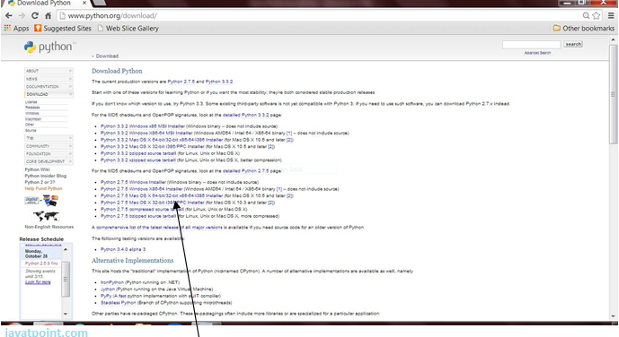

2. Having downloaded the Python distribution now execute it. Double click on the downloaded software. Follow the steps for installation:

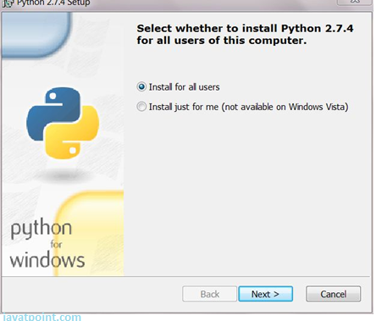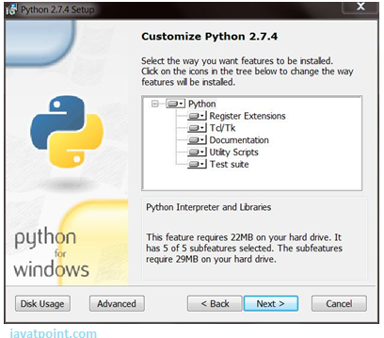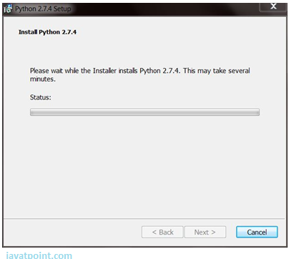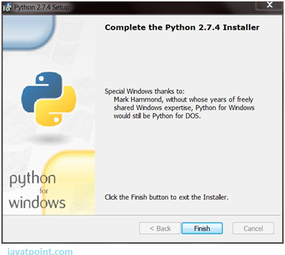

Click the Finish button and Python will be installed on your system.